SPRINT3

|  |  |
| --- | --- |
| Date | 13November2022 |
| TeamID | PNT2022TMID17177 |
| ProjectName | Project – Smart Farmer-IoT Enabled smartFarmingApplication |

Creating Mobile app using MIT app InventorSMARTFARMER APPLICATION

AppInventor+IoTcanworktogethertohelpusunderstand,andchange,oureveryday lives.

Blocks

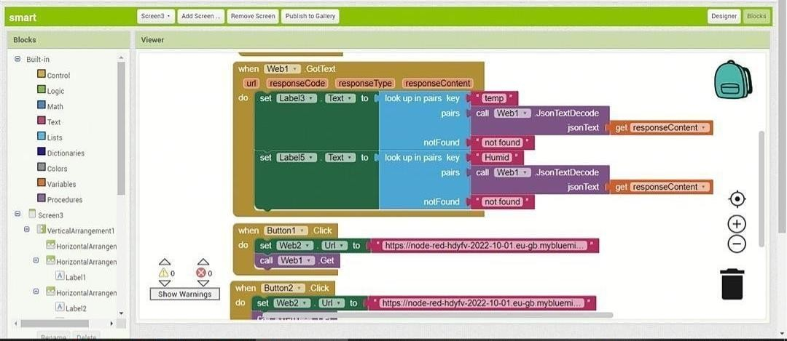

QRCode for APKdownload:

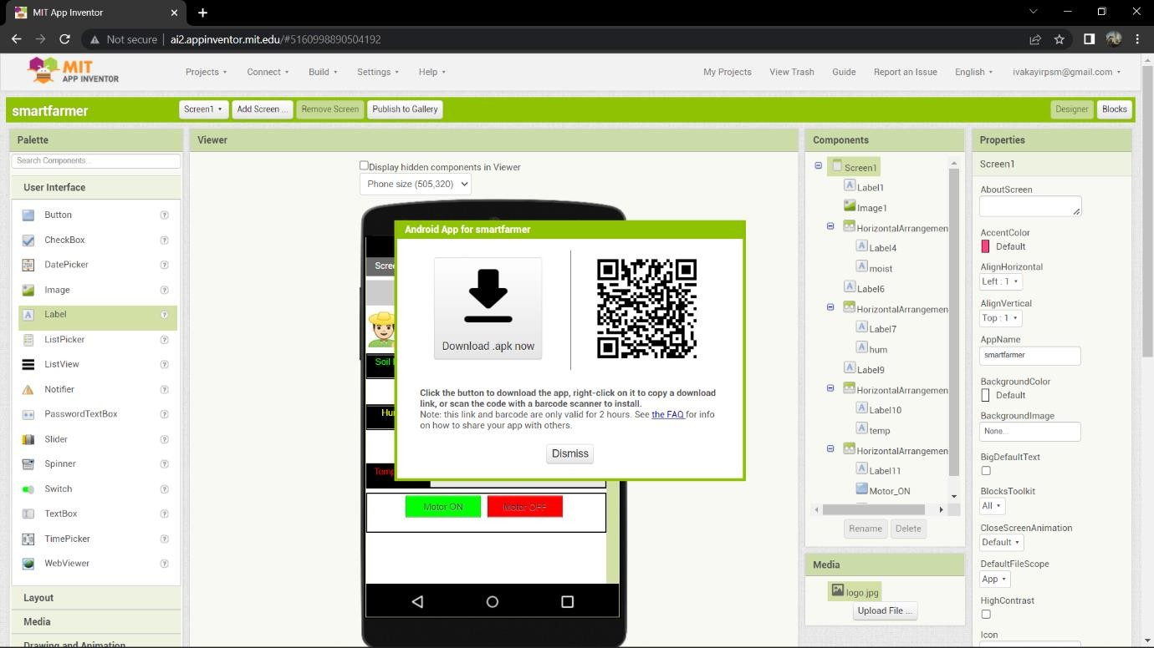

OutputScreeninMobile:

